Rossmoyne Senior High School

Examination, Semester 1 2010

Question/Answer Booklet

MATHEMATICS 3C/3D

Section One:
Calculator-free

Student Name

Goh | Robinson | Longley | Birrell | Whyte

Time allowed for this section
Reading time before commencing work: 5 minutes
Working time for this section: 50 minutes

Material required/recommended for this section

To be provided by the supervisor
This Question/Answer Booklet
Formula Sheet

To be provided by the candidate
Standard items: pens, pencils, pencil sharpener, eraser, correction fluid, ruler, highlighters

Special items: nil

Important note to candidates
No other items may be used in this section of the examination. It is your responsibility to ensure that you do not have any unauthorised notes or other items of a non-personal nature in the examination room. If you have any unauthorised material with you, hand it to the supervisor before reading any further.

Structure of this paper

Section | Number of questions available | Number of questions to be answered | Working time (minutes) | Marks available
Section One:  Calculator-free | 9 | 9 | 50 | 40
Section Two:  Calculator-assumed | 13 | 13 | 100 | 80
 |  |  |  | 120

Instructions to candidates

1. The rules for the conduct of Western Australian external examinations are detailed in the Year 12 Information Handbook 2010. Sitting this examination implies that you agree to abide by these rules.

2. Write your answers in the spaces provided in this Question/Answer Booklet. Spare pages are included at the end of this booklet. They can be used for planning your responses and/or as additional space if required to continue an answer.
  - Planning: If you use the spare pages for planning, indicate this clearly at the top of the page.
  - Continuing an answer: If you need to use the space to continue an answer, indicate in the original answer space where the answer is continued, i.e. give the page number. Fill in the number of the question(s) that you are continuing to answer at the top of the page.

3. Show all your working clearly. Your working should be in sufficient detail to allow your answers to be checked readily and for marks to be awarded for reasoning. Incorrect answers given without supporting reasoning cannot be allocated any marks. For any question or part question worth more than two marks, valid working or justification is required to receive full marks. If you repeat an answer to any question, ensure that you cancel the answer you do not wish to have marked.

4. It is recommended that you do not use pencil except in diagrams.

Section One: Calculator-free (40 Marks)

This section has nine (9) questions. Answer all questions. Write your answers in the space provided.

Spare pages are included at the end of this booklet. They can be used for planning your responses and/or as additional space if required to continue an answer.
  - Planning: If you use the spare pages for planning, indicate this clearly at the top of the page.
  - Continuing an answer: If you need to use the space to continue an answer, indicate in the original answer space where the answer is continued, i.e. give the page number. Fill in the number of the question(s) that you are continuing to answer at the top of the page.

Suggested working time for this section is 50 minutes.

- (5 marks)
There are four corridors in a hospital which lead from the Emergency Room to the Examination Room and three which lead from the Examination Room to the X-Ray Department.
Determine the number of different paths that an orderly can take in wheeling a patient
(a) from the Emergency Room to the X-Ray Department via the Examination Room
( 1 marks)

(b) from the Emergency Room to the X-Ray Department via the Examination Room and return, if
(i) it is possible to return via the same corridors
( 2 marks)

(ii) the corridors used in the return journey must differ from those used in getting to the X-Ray Department
( 2 marks)

- ( 4 marks)
Differentiate the following, without simplifying:

(a) 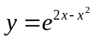
( 2 marks)

(b) 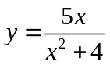
( 2 marks)

- ( 3 marks)
The probabilities of two events  and  are given by: 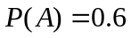 and 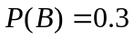
Calculate 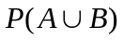 given that and are independent.
( 3 marks)

- ( 4 marks)
Find the maximum and minimum values over the interval 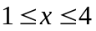 of the function

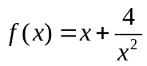
( 4 marks)

- ( 3 marks)
Two events, A and B, from a given events space are such that 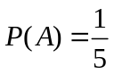 and 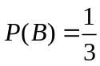.
(a) Calculate 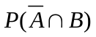 when 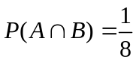
( 2 marks)

(b) Calculate when A and B are mutually exclusive
( 1 marks)

- ( 4 marks)
Determine the following integrals:
(a) 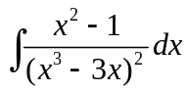
( 2 marks)

(b) 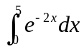
( 2 marks)

- ( 6 marks)
A continuous random variable has a uniform distribution in the interval 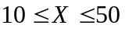

Determine (a) 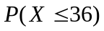
( 2 marks)

(b) 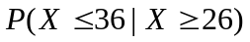
( 2 marks)

(c) The value of given 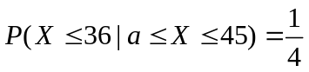
( 2 marks)

- ( 4 marks)
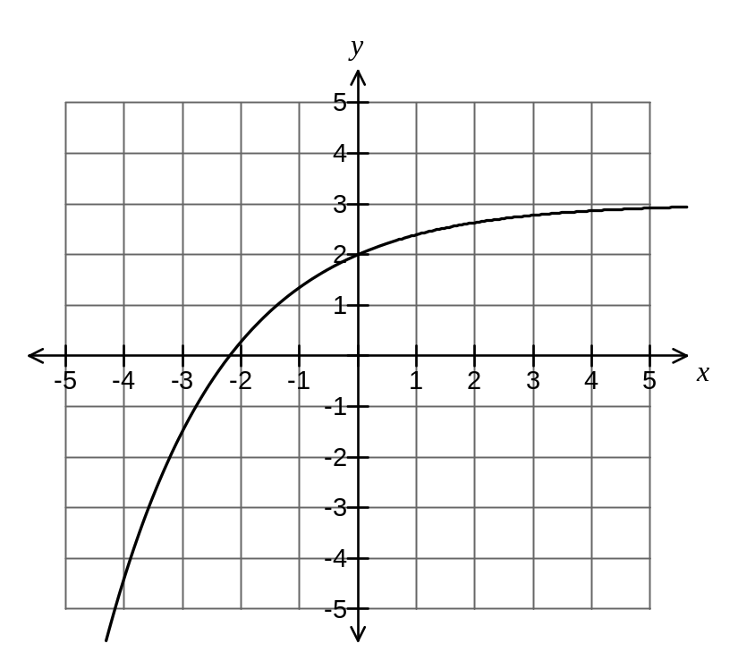The graph of 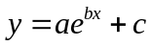 is shown below. The graph passes through the point 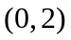, and 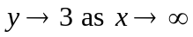.

(a) Is positive or negative? Justify your answer.
( 1 mark)

(b) Evaluate and .
( 2 marks)

(c) Sketch on the same axes the graph of 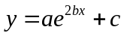
( 1 mark)

- ( 7 marks)
Determine all turning points and points of inflection of the function 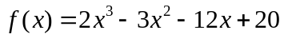, and use these to sketch its graph.
( 7 mark)

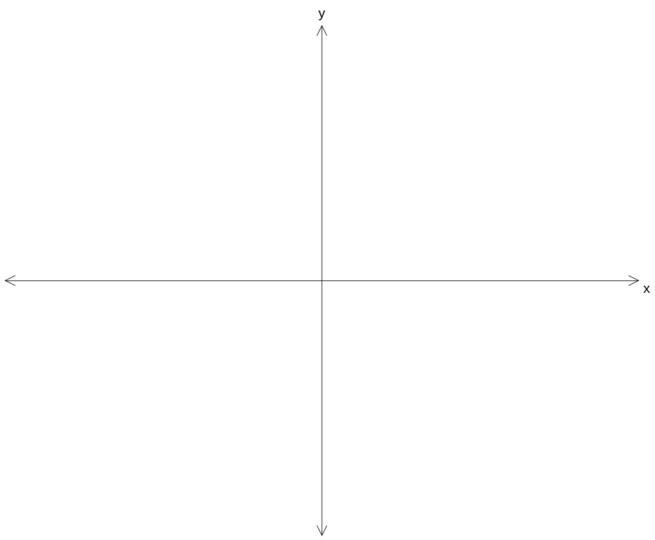
f(x)
x

- ( 5 marks)
When driving to work, a motorist encounters 8 traffic lights. The probability that he will be stopped at any one of these traffic lights is 1/3. The motorist is late to work if be is stopped 6 or more times.
Write an expression, but do not evaluate, giving the probability that
(a) He does not get stopped at any of the lights
( 1 mark)

(b) He gets stopped at exactly 2 of the lights
( 1 mark)

(c) He gets stopped at 7 of the lights, given that he is late to work
( 2 mark)

(d) He is late, given that he is stopped 7 times
( 1 mark)

Additional working space
Question number(s):
Additional working space
Question number(s):

